TALKIN' BOUT A REVOLUTION
by Tracy Chapman

Don't you know
They're talkin' bout a revolution
It sounds like a _____________
Don't you know
They're talkin' about a revolution
It sounds like a _____________
While they're standing in the _____________ lines
Crying at the doorsteps of those armies of salvation
Wasting time in the _____________ lines
Sitting around waiting for a _____________
Poor people gonna rise up
And get their ___________
Poor people gonna rise up
And take what's _____________
Don't you know
You better __________________________
Oh I said you better
__________________________
Finally the tables are starting to turn
Talkin' bout a revolution

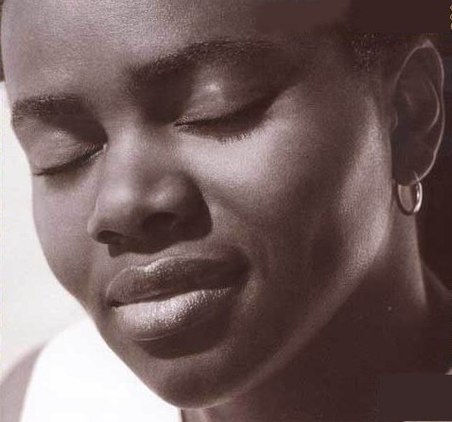
TALKIN' BOUT A REVOLUTION
by Tracy Chapman
Don't you know
They're talkin' bout a revolution
It sounds like a whisper
Don't you know
They're talkin' about a revolution
It sounds like a whisper
While they're standing in the welfare lines
Crying at the doorsteps of those armies of salvation
Wasting time in the unemployment lines
Sitting around waiting for a promotion
Poor people gonna rise up
And get their share
Poor people gonna rise up
And take what's theirs
Don't you know
You better run, run, run...
Oh I said you better
Run, run, run...
Finally the tables are starting to turn
Talkin' bout a revolution

