The First Thanksgiving
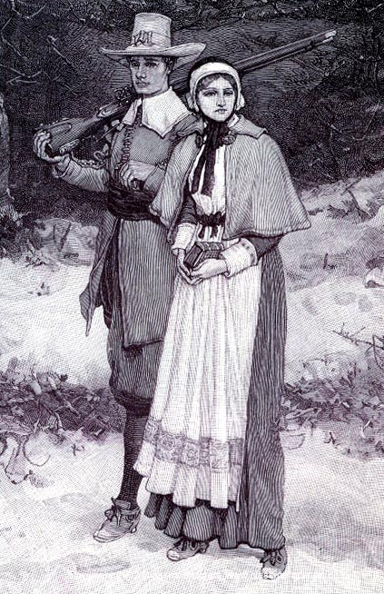 The Pilgrims

The first people who lived in America are called American Indians. We think they came here from Asia thousands of years ago. There used to be about 15 million American Indians, living all around what is now America.

The Pilgrims came to America from Europe in 1620. They didn’t know how to live here. They didn’t know what to eat. They didn’t know what fruits or vegetables to grow. The winter was colder than where they came from. Some Pilgrims were so cold and hungry they went to the graves of American Indians to get the food and clothing of dead Indians. Many Pilgrims died that first winter in America.

The American Indians taught the Pilgrims how to live in America. They showed the Pilgrims how to grow food, and what to eat. Fewer Pilgrims died because of their help. Every year, the American Indians had a huge feast in the fall. In 1621, the American Indians invited the Pilgrims to come to their fall feast. Today, Americans celebrate Thanksgiving in November. It's a holiday to remember when the American Indians helped the Pilgrims and invited them to their fall feast.

For a short time, the Pilgrims and American Indians were friends. But more and more people came from Europe. They killed the animals the American Indians ate. They also took the best land from the Indians. Sometimes they killed the Indians, too.

The Pilgrims took land from the Indians so they could grow food and build cities. Many times, they promised to leave them alone. Almost every time, they broke their promise. By the end of the 1800s, there were less than one million American Indians. There are over four million American Indians today.

Vocabulary
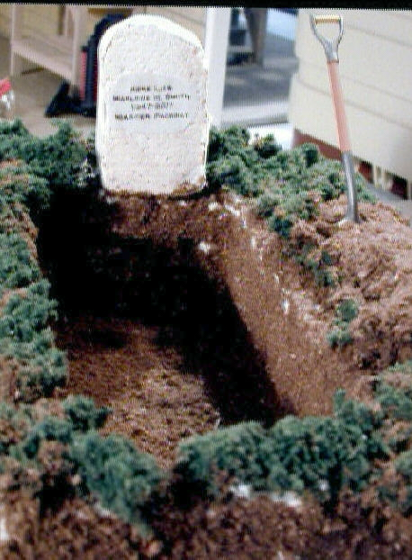 A grave
- Pilgrims – noun – Some of the first Europeans to come to America. “We studied the Pilgrims in school today.”
- grave – noun - Where you put a dead person in the ground. (see picture) “My family visits my grandfather's grave every year.”
- feast – noun – A big meal, or to eat a lot of food. “We had a feast at my cousin's graduation party.”
- invite – verb – To ask someone to come to something. “I invited 100 people to my birthday party, but nobody came.”
- took – verb – Past tense of “take.” “Jenny took the bus to school.”
- leave someone alone – verb – To not bother someone. “I want my brother to stop hitting me and leave me alone.”
- break your promise – verb – To not do what you said you would do. “My boss said he would pay me under the table, but he broke his promise.”
Vocabulary Practice

1.___ Pilgrims A. To not bother someone
2.___ grave B. Some of the first Europeans to come to America
3.___ break your promise C. To move to another country
4.___ feast D. To not do what you said you would do
5.___ invite E. Where you put a dead person in the ground
6.___ took F. A big meal, or to eat a lot of food
7.___ leave someone alone G. Past tense of “take”
8.___ ________________ H. To ask someone to come to something

Questions

1. Who were the Pilgrims? Why did they come to America?

2. Why did the Pilgrims need help?

3. What happened to American Indians in the US?

4. Are there any American Indians today?

5. What are some problems American Indians have?

