The Turtle and the Swans
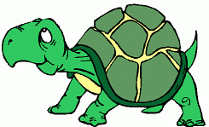 The turtle

Many years ago a turtle lived in a beautiful blue lake. Two white swans came to the lake every day for food and soon became good friends with the turtle. One day, the swans invited the turtle to visit their home. The turtle said, “But how will I get there? I can’t fly, and I walk very slowly.”

“We can carry you there,” said the swans, “But you must promise one thing.”

“What is it?” asked the turtle.

“You must promise not to open your mouth or speak to anyone along the way.”

“No problem,” said the turtle, “I can keep my mouth shut!”

The swans were very happy. They picked up a stick and asked the turtle to bite the middle of it. Then they each held one end and flew off into the sky.
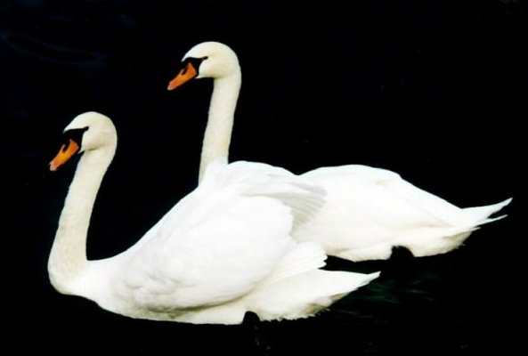 The swans

As they flew over a village, some boys playing in the street saw the turtle and shouted, “Look! The swans are carrying a turtle. A turtle in the sky!” They shouted and jumped and chased the turtle and the swans. The boys made the turtle very angry. He wanted them to leave him alone, but couldn’t open his mouth to speak.

Soon they flew over the king’s palace. Everyone in the palace wanted to see the strange sight. The king’s cook came out and shouted, “What a fat turtle! I wish it would fall, it would make a great dinner for the king!”

At this the turtle could be silent no longer. He forgot his promise not to open his mouth. He shouted at the cook, “Eat the wood that burns in your stove!” But as he said it he fell down, down, down to his death with a loud crash right in the middle of the palace. The swans flew home alone, having lost their friend.

When the turtle’s pride got the better of him, he forgot that it is often better to stay silent than answer with angry words. Because of his anger he lost his life.

Vocabulary
- invite – verb – To ask someone to come to something, like a party or a wedding.
“I invited the class to my birthday party.”
- chase – verb – To run after something. “My dog likes to chase cats.”
- palace – noun – A big house where a king lives. “The palace had 1000 rooms.”
- crash – noun – A loud noise. “I heard a crash when the rock hit my window.”
- pride – noun – Your feelings that you are a good person. “I have my pride, but not too much.”
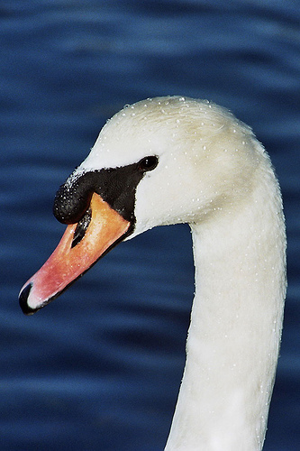
Questions
1) Did the turtle know he would fall and die when he opened his mouth to talk? Why did he do it?

2) Did the turtle die because of the swans? Did the swans do enough?

3) Have you ever said something that was a mistake to say?

4) When is it good to talk? When is it good to keep silent?

5) Do you know anyone like the turtle? Are you ever like him?

Animals and Their Personalities
Everyone knows animals can’t talk. But in stories, we often give different animals different personalities. For example, a turtle is usually slow but finishes anything he starts. What kinds of personalities would you give the animals below?
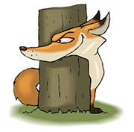
1. A fox is __________________________________________________.

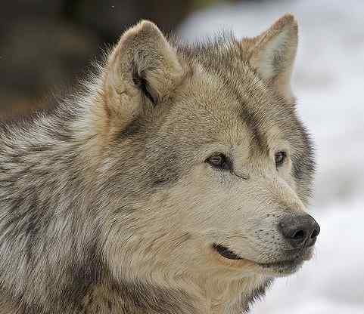
2. A wolf is ______________________________________________.

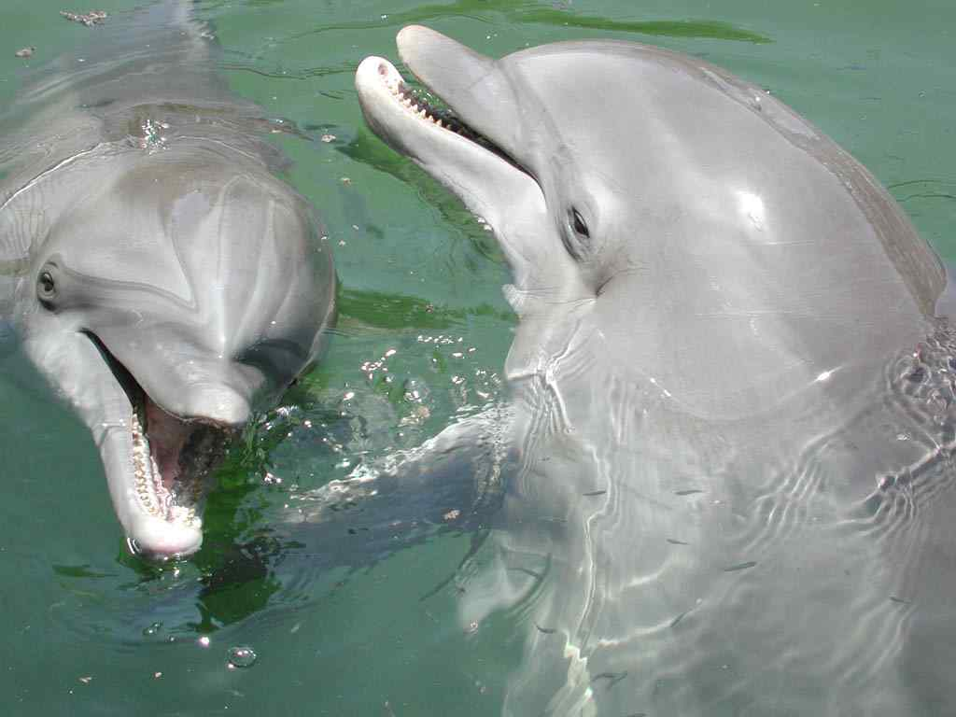
3. A dolphin is ______________________________________.

