Watergate and President Nixon
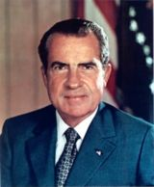 President Richard Nixon,
1913 to 1994

Richard Nixon was the President in 1972. It was an election year, and he was trying get re-elected. Nixon was a Republican. The Democrats' office was in the Watergate Hotel in Washington, DC.

On June 17, 1972, a security guard at the Watergate saw that someone had put tape on the parking lot door so it wouldn't lock. He thought the janitors did it and took it off. Later that night he saw tape on the door again, so he called the police. The police arrested 5 men who had broken into the Democrats' office. The men worked for the Republicans. They had broken into the office three weeks before to put in microphones. The microphones didn't work, so they were trying to fix them.

This was big news. President Nixon said that he didn't know about the 5 men. But many people were asking how much Nixon really knew. Nixon hired a special lawyer, Archibald Cox, to investigate what happened. The lawyer and politicians asked the President's staff many questions. They learned that Nixon had microphones in his office, and tape recorded all of his conversations in the White House. Everyone was surprised. Archibald Cox asked for the tapes. Nixon said he didn't have to give him the tapes, because he was the President. He told the lawyer to stop asking for them.

Archibald Cox still wanted the tapes, so Nixon fired him. This made millions of Americans mad. Nixon had to hire a new lawyer and give him the tapes. The tapes showed that many of Nixon's staff lied to Cox. This was illegal, and many of them went to jail. Then they found one more tape. This tape was from a few days after the Watergate break-in. President Nixon was talking to his staff manager about how to lie to the people investigating Watergate.

After people heard this tape, almost no one believed the President. Politicians in Washington impeached him. Impeach means they believed the President broke the law. Nixon resigned in 1974, and the Vice President, Gerald Ford, became President. A lot of people thought Nixon was going to go to jail. But less than a month later Ford pardoned Nixon. Richard Nixon was only the second President to be impeached, and the first to resign. He changed how Americans thought about the President.

Vocabulary
- elect – verb – When people vote and choose you to be a leader. “Ronald Reagan was elected Governor of California in 1966, and elected President of the US in 1980.”
- hire – verb – To give someone a job. “They hired a few more people at work this week.”
- investigate- verb – To study something seriously. “The police are investigating a murder.”
- staff – noun - People who work to help someone else. “The mayor has a staff of 12 people.”
- resign – verb – When you quit an important job. “The Mayor resigned after getting arrested.”
- pardon – verb – When the Governor or President says you don't have to go to jail for breaking the law.”
Questions
1. Why did the 5 men break into the Watergate? Who did they work for?

2. Who was Archibald Cox? Why did Nixon hire him? Why did Nixon fire him?

3. What was on the last tape? What happened after people learned about it?

4. Why do you think President Ford pardoned Nixon?

5. How do you think Watergate changed how Americans thought about the President?

6. Do they pardon people in your country? Who was pardoned? When?

Impeachment and Conviction
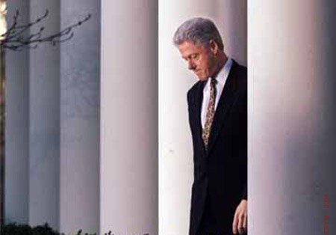 President Bill Clinton, born 1946

Congress makes the laws for the United States. There are two parts of Congress: the House and the Senate. The 435 members of the House and the 100 members of the Senate both vote to make new laws.

Impeachment is a way for the US to make a bad President quit. It happens in two parts. The first part is when most of the politicians in the House vote that they believe the President has done something wrong that was very serious. When this happens, we say the President is “impeached.”

Next, the Senate must vote to convict. This means that they agree with the House. Two-thirds of the Senate must vote to convict the President. After this the President must quit, and the Vice President becomes the new President.

Bill Clinton was the last President impeached. In 1998, he was impeached for lying about having sex with a young woman who worked for him. However, the Senate did not convict him, and he did not have to quit. The first impeached President was Andrew Johnson, back in 1868. He was not convicted. President Nixon resigned when he learned the Senate was going to convict him.

