We Shall Overcome

We shall overcome  We shall overcome  We shall overcome some day  Darlin', deep in my heart  I do believe  We shall overcome some day  We'll walk hand in hand  We'll walk hand in hand  We'll walk hand in hand some day  Darlin', deep in my heart  I do believe  We'll walk hand in hand some day  We shall live in peace  We shall live in peace  We shall live in peace some day  Darlin', deep in my heart  I do believe  We shall live in peace some day  We are not afraid  We are not afraid  We shall overcome some day  Here in my heart,  I do believe  We shall overcome some day  We shall overcome  We shall overcome  We shall overcome some day  Darlin', deep in my heart  I do believe  We shall overcome some day  We shall overcome some day | shall – verb – Old English for “will.”  Darlin' – noun – Short for “darling,” what you call someone close to you  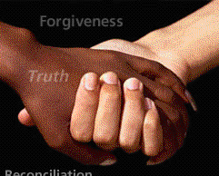  hand in hand – An expression for holding hands

Questions
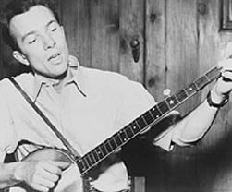 Pete Seeger made this song
famous in 1970.

1. What do you think “overcome” means?

2. This song was first written in 1945. What problem did they want to overcome? (It’s not about the war.)

3. In the 1960s, they added the parts about “walking hand in hand.” What problem did they want to overcome?

4. Why does the song say, “I do believe”? Why does the song say, “some day”?

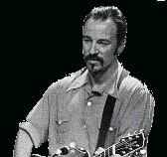
Bruce Springsteen

This version of “We Shall Overcome” was sung by Bruce Springsteen in 2006. Bruce is one America's most famous stars. He has recorded 24 albums in 33 years, and sold millions of albums.

Bruce was born in New Jersey in 1949. His father was a bus driver and his mother was a secretary. He writes songs about regular people who need to work to make enough money. When he started singing, Bruce played many concerts in New Jersey. Most musicians only play for an hour or two; Bruce's concerts often lasted for four hours. He became famous as a musician who worked hard for his fans.

Bruce is also famous for caring about people. In the 1990s, some politicians in California wanted to make laws to hurt immigrants. At every concert in California, Bruce told his fans why this was a bad idea. A few fans asked for a refund. He always gave them their money back, but he never changed his mind. Today, Bruce sings about poor people, the Iraq war, and New Orleans.

Vocabulary
- version – noun – A different copy of something. “This is a newer version of the song.”
- record – verb – To copy something onto a tape. “I recorded a TV show last night.”
- fan – noun – Someone who likes something a lot. “I'm a big rock and roll fan.”

