When Regular People Stand Up
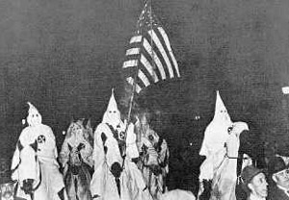Members of the KKK

A man named L.A. Blackman lived in a small town in South Carolina. In 1956, he was the local president of a group called the NAACP. The NAACP helped black people get their rights around the US.

There was another group around the US at that time. It was called the KKK, and they believed America was only for white people. They often met at night, put on masks, and hurt or killed black people who tried to get their rights. They also wanted to make Latino immigrants, Irish people and Catholics leave the US.

The KKK had a protest against L.A. Blackman in his small town. Blackman went to it. One man from the KKK was standing on the back of a truck, talking about black people and voting. When he finished, he asked if anyone had anything to say about Mr. Blackman.

L.A. Blackman went to the front of the protest. He climbed up on the truck and calmly said, “I have been here seventeen years and I have no idea of leaving. I am going to stay here.” The KKK was so surprised that they all left the protest.

Vocabulary
calmly – adverb – Relaxed, not excited or afraid. “When the police pulled me over I calmly gave them my drivers license and insurance.”

Questions
1. In the story, what did the KKK expect to happen?

2. Why do you think L.A. Blackman did what he did? How was he able to be so calm?

3. Who do you think was in the KKK? What jobs did they have in the day time?

4. Why do you think the members of the KKK in the picture are holding an American flag?

