When Regular People Stand Up, Part 2
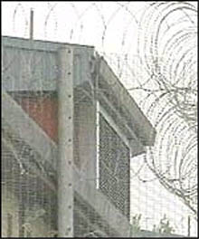 Salim Rambo's jail

Salim Rambo wanted to live. He was a young man from the Democratic Republic of Congo, a large country in Africa. His government believed he was a terrorist, and wanted to kill him. Salim escaped to England. He was 23 years old.

Salim was one of millions of refugees around the world. A refugee is someone who must escape their country because they will be hurt or killed.

In England, Salim applied for asylum. Asylum is when the government gives you a visa because you're a refugee. If you don't get asylum, you usually get deported. The government refused to give Salim asylum. They sent him to a jail for undocumented immigrants. They said they were going to deport him the next day.

Salim had an idea. He called an organization that helped refugees. Someone from the organization bought a ticket on Salim's plane. Before the plane took off, the person from the organization stood up. He told everyone, “There is a refugee on this plane who will be killed if he goes back to his country. I will not sit down until the government gives him asylum.”

People from the airline asked him to sit down, but he refused. He wanted to stop the airplane. The plane could not take off when he was standing up. The police arrested him, but then the pilot of the plane refused to take off. After two hours, Salim went back to jail. He got out soon after, and he is still free today.

Vocabulary
1. escape - verb - To get away from something bad. "We escaped from the burning building."
2. apply - verb - To try to get something. "I applied for a job at that new restaurant today."
3. refuse - verb - To say "no" to. "I refuse to take a job that pays less than $10 an hour."
4. take off - When an airplane goes in the air. "Our flight will take off in about 15 minutes."

Please write the definition of “pilot,” and a sentence with “pilot.”

5. pilot - noun - _______________________________________________________________

"The pilot __________________________________________________________________"
Conversation Questions

1. Why did Salim Rambo escape his country? Why was he afraid to go back?

2. Why do you think England didn't give Salim asylum?

3. Why did the man on the plane stand up? Why did the pilot refuse to take off?

4. Do you think it was a good idea for the man to stand up?

What is Direct Action?
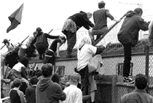 People climb the fence at Salim's jail

There are many ways to solve problems, or change something you don't like. One way is "direct action." That's when you try to do what you want to do, even if it's difficult or illegal. You don't wait for other people to do things for you. Rosa Parks sat in the front of the bus, where only white people could sit. That was one kind of direct action.

The group that helped Salim Rambo also used direct action. They wanted to talk to the refugees at the undocumented immigrant jail in England. The government said that you must know the names of the people you want to talk to. But no one knew their names, and the refugees didn't know anyone's phone number. The group asked many times, wrote letters, and asked lawyers to help them, but the government refused.

The government was still deporting refugees. Some of them had no friends to help them. The group stopped waiting. One day, they went to the jail and climbed up the fence. (see picture) This way they could talk to the refugees inside. They learned many of their names that way, and gave them their phone number. They started to visit refugees the next day. One of them was Salim Rambo.

Questions
1. Is it ok to use direct action? When?

2. What are other kinds of direct action?

