“Who's the Boss?” - Note to teachers:

This story was inspired by the Naomi Klein excellent documentary The Take, about the factory takeover movement in Argentina. “Who's the Boss” goes well with the Haymarket story; I teach “Who's the Boss” first. Oh, and to answer Discussion Question 6, the name FaSinPat is short for “Factory without bosses” in Spanish.
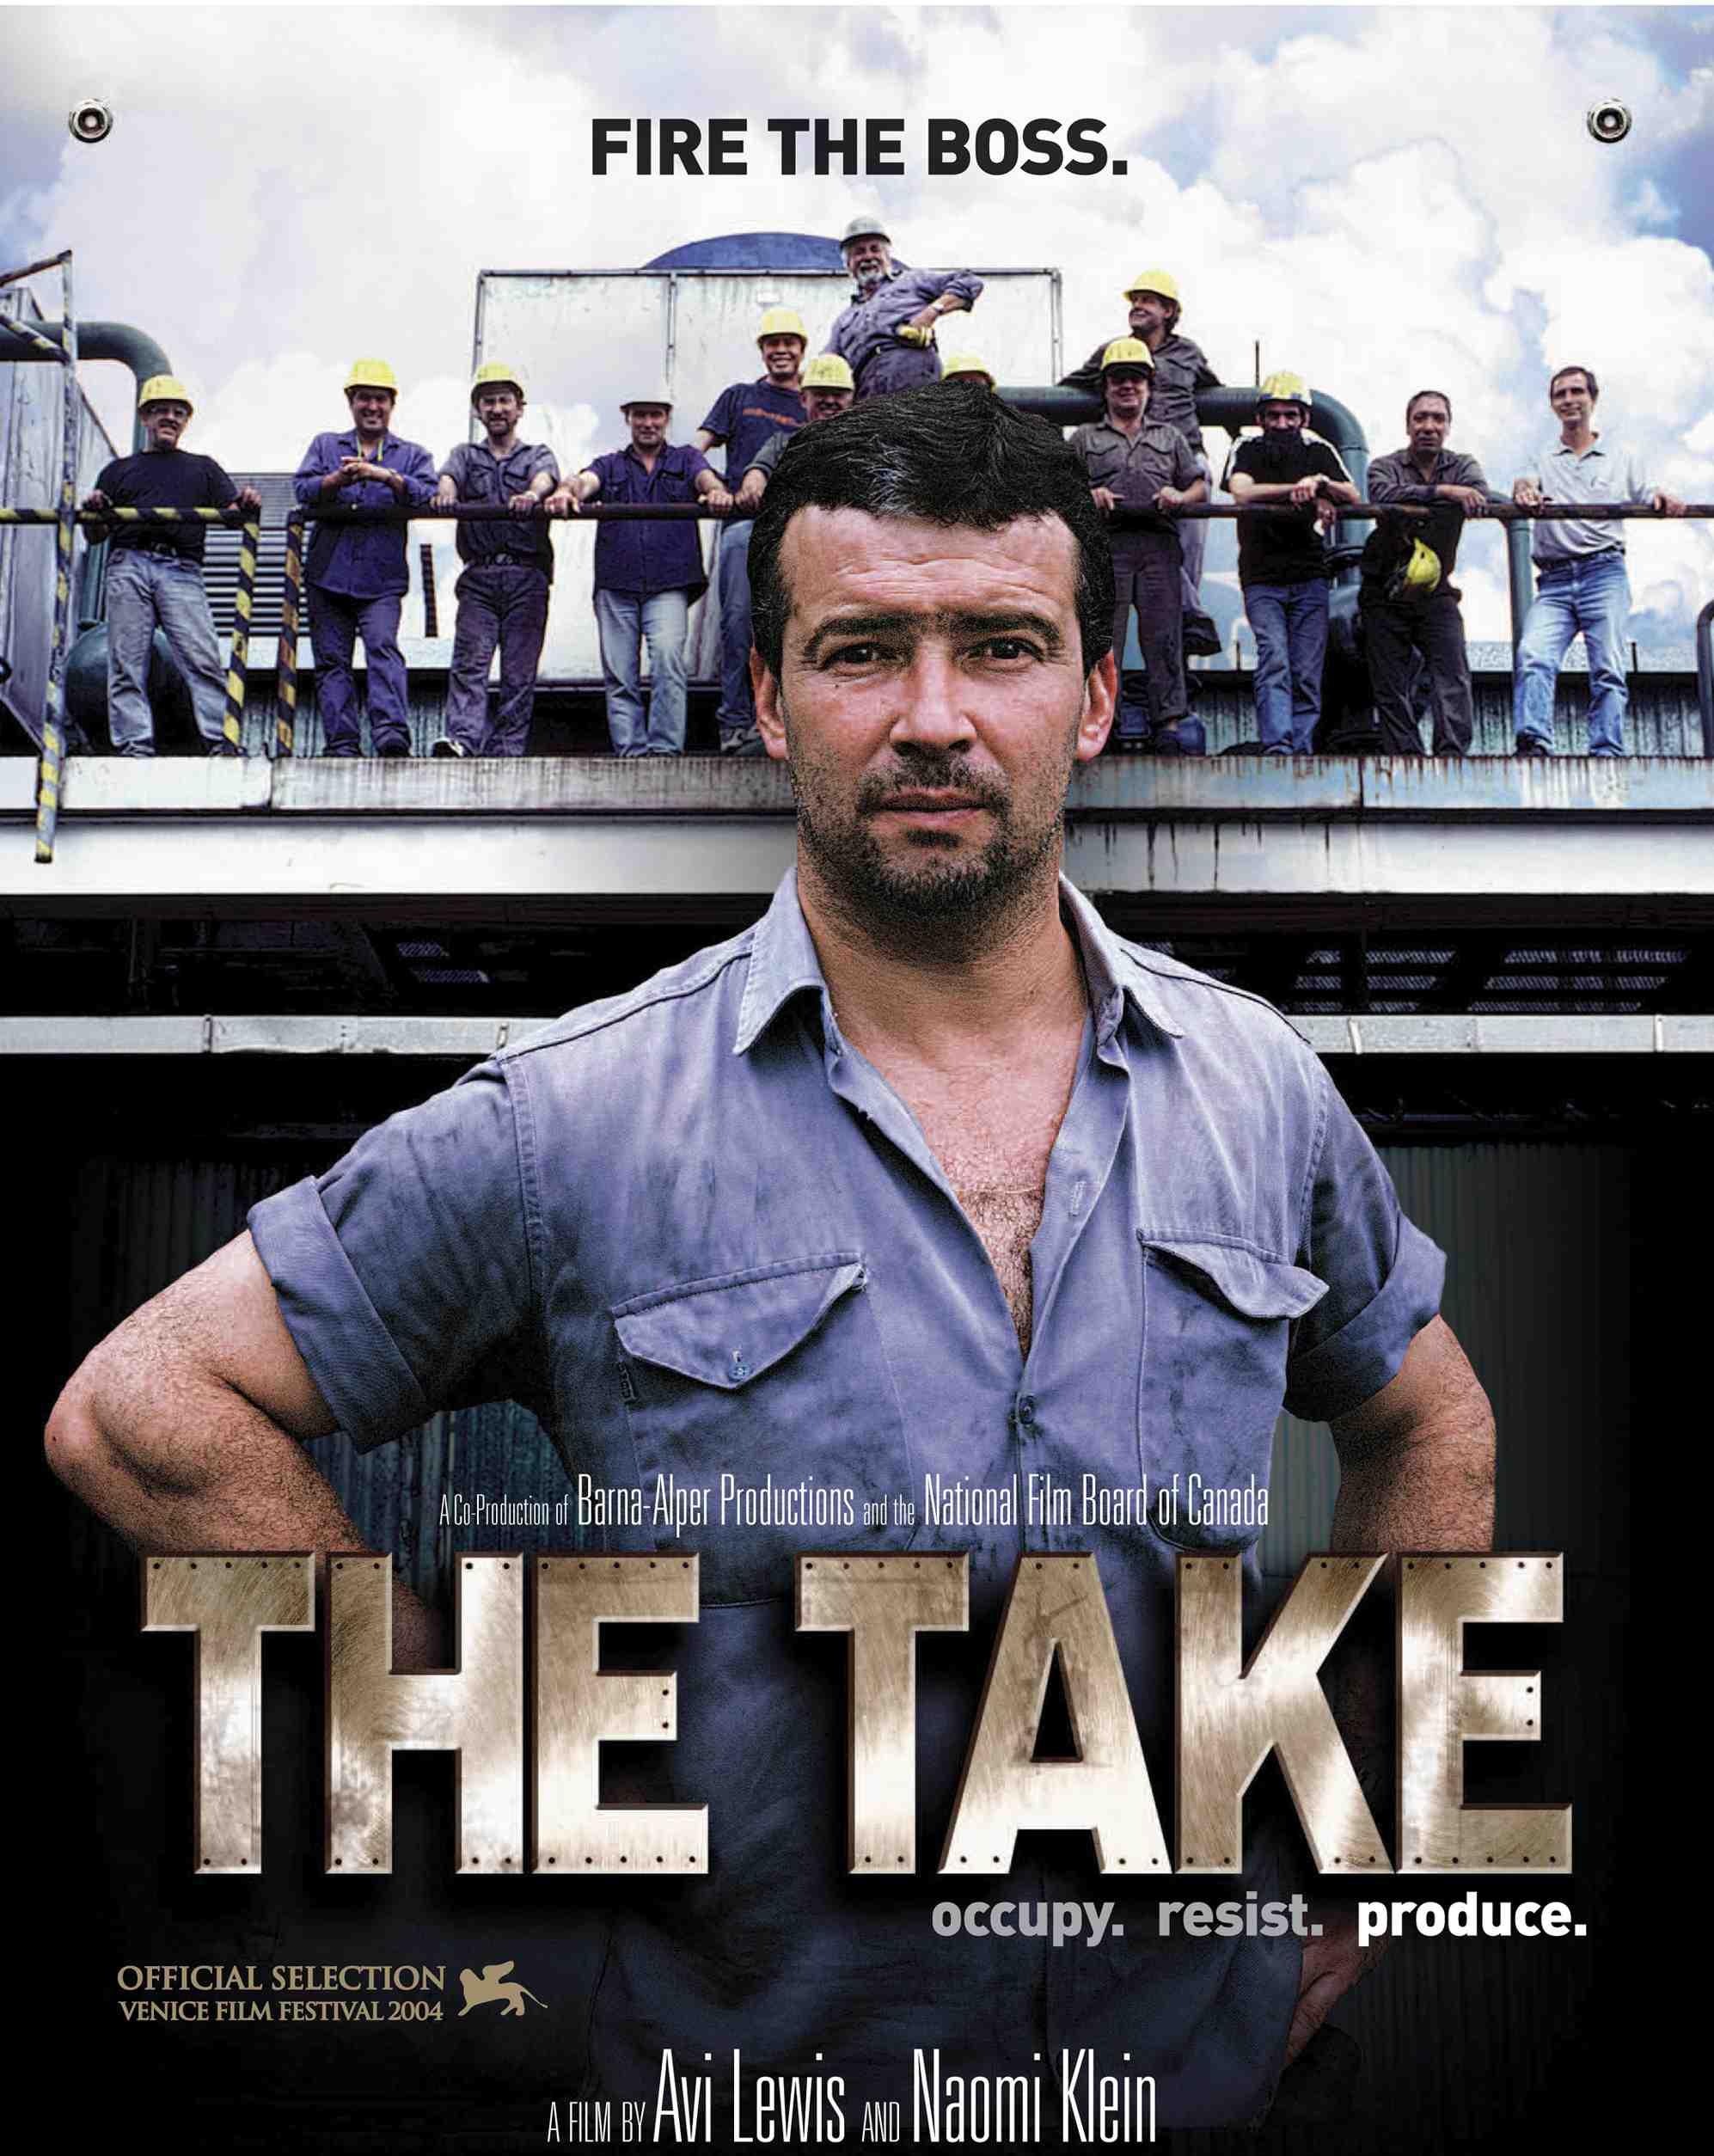
Who’s the Boss?
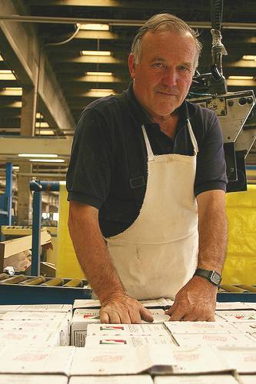 A worker at Zanon

Argentina used to be one of the richest countries in the world. The government borrowed lots of money to build new highways and factories. One of those factories was called Zanon. It was built on public land with public money the boss borrowed from the government.

The good times for Argentina ended in 2001. That year, people believed that the economy was not doing well. Argentines tried to take all their money out of the bank, and banks had to turn off their ATMs. Rich people sent their money to banks in other countries. The government couldn't pay back all the money it had borrowed.

The good times were also over for Zanon. The workers needed more money, and the boss didn’t want to give them any. The boss closed the factory, fired all the employees, and tried to sell the machines in the factory. He never paid back the money he borrowed from the government.

The workers needed their jobs. They stayed in the factory and continued to work. They said that because the factory was built with public money on public land, and because the boss never paid back the government, the people owned Zanon. They said, “The boss needs us, but we don’t need the boss.”

The workers made the factories a democracy. Everyone received the same wages, and they voted on decisions. Soon, Zanon was making more money than before. The workers also helped the neighborhood. Poor people in the city had asked the government for a clinic for 20 years. The workers at Zanon built them a clinic in three months.

The old boss of the factory was angry. He wanted Zanon back. He asked the police to make the employees leave the factory. They tried, but every time the police came, the workers and the neighbors made the police leave.

Zanon hired 170 more workers, and today they have more than 400 employees. There are hundreds more businesses like Zanon all around Argentina. Workers make the decisions and pay each other the same wages. Not all of them are successful, but all of them try hard to help their neighbors and their country.

Vocabulary
- public – adjective – Something that belongs to everyone. “This is a public beach, so anyone can swim here.”
- wages – noun – How much money you make. “Wages have gone up, but so have expenses.”
- decision – noun – What you choose to do. “Coming to the US was a big decision for us.”
Vocabulary Practice
Word | Definition
1.___ public  2.___ pay back  3.___ wages  4.___ decision  5.___ democracy  6.___ ___________ | a. How much money you make.  b. What you choose to do.  c. When everyone talks about and decides what to do.  d. Something that belongs to everyone.  e. To give money back to who you borrowed it from.  f. When you ask for money you will pay back later.
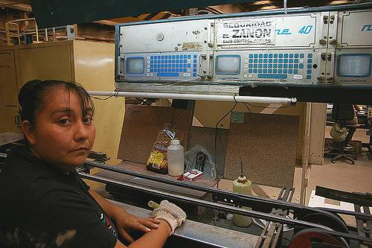 A worker at FaSinPat
Questions

1. Do you think it was right for the workers to take the factory?

2. Why do you think the factory made more money when the workers made the decision?

3. Why did the workers build clinics for the people of the city?

4. What happened when the police came? Why?

5. Why did the workers say they didn't need the boss? Do you need your boss?
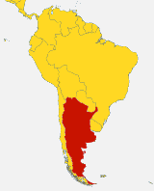 Argentina

6. After the workers made the factory a democracy, they changed the name to FaSinPat. Why do you think they changed the name? Why did they choose FaSinPat?

