Why Make a Go Bag?
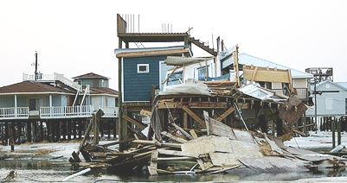
A home destroyed by Hurricane Katrina
photo by Au Tiger

We need help for emergencies. Usually, the local government helps us. If your house catches fire, firefighters will come in just a few minutes. If you have a heart attack, an ambulance will quickly come and take you to the hospital. The government has a system with firefighters, hospitals, the police and 911. This system works best for emergencies that only hurt a few people at a time.

This system does not work well for disasters. After an earthquake, 1000 people may need to go to the hospital. But 1000 people can't call 911 at the same time. And the earthquake may have destroyed the hospital. It may also have destroyed the 911 office!

After Hurricane Katrina in 2005, thousands of people in New Orleans didn't have food, water, electricity or gasoline. Their homes were destroyed, and they couldn't drive anywhere because the streets were flooded. (see picture) Hospitals around the city were closed. In poor people's neighborhoods, it was like this for weeks.
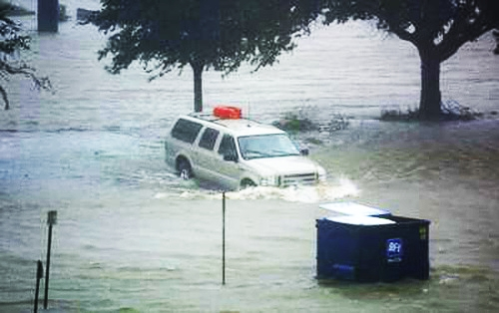
Hurricane Katrina flooded the streets.
photo by Au Tiger

We learned that the government can't always help us. The government says we have to be ready to live for three days without their help. One way we can help ourselves during a disaster is with a Go Bag. A Go Bag is a backpack or bag with three days of supplies.

A disaster could happen in the middle of the night, so you have to have clothing in your Go Bag. There could be lots of broken glass on the ground, so you need good shoes. It will be difficult to get medicine, so you need to have your medicine in your Go Bag, too.

Your Go Bag has to be somewhere you can easily find it. Sometimes people put theirs in the basement. This is a terrible place for a Go Bag! If there is an earthquake, they will not be able to get it. Most of us don't have a Go Bag – but all of us need one.

Vocabulary
- destroy – verb – To break something so that it cannot be used. “The fire destroyed my home."
- supplies – noun – Things you need. “We buy our school supplies every September.”
Vocabulary
- ___ | destroy | a. A very serious problem that can hurt or kill you.
- ___ | supplies | b. A backpack or bag with three days of supplies in it.
- ___ | emergency | c. Things you need.
- ___ | disaster | d. When there is lots of water somewhere.
- ___ | flooded | e. A situation that can hurt or kill hundreds or thousands of people.
- ___ |  | f. To break something so that it cannot be used.

Questions
1. What happened in New Orleans after Hurricane Katrina?

2. Why doesn't 911 work well for disasters?

3. What supples do you need in your Go Bag?

4. What's a bad place to put your Go Bag? What's a good place?

5. Who needs a Go Bag? When should you make one?

What Do You Need in Your Go Bag?

Please name these items that you will need if there is a disaster.

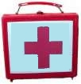  1. ____________________ | 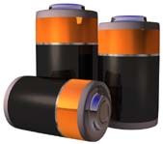  2. ____________________ | 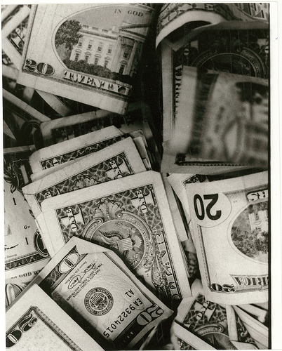  3. (a little) ________________
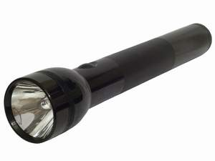  4. ____________________ | 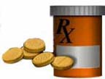  5. ____________________ | 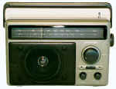  6. ____________________
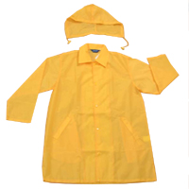  7. ____________________ | 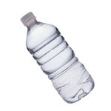  8. ____________________ | 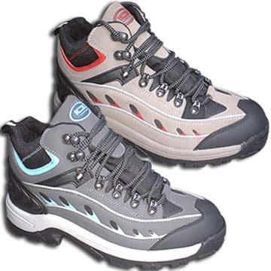  9. ____________________

