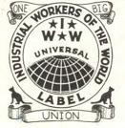
The Wobblies

Unions in America help workers get more money, benefits and respect. There’s a union for almost everyone - they can’t discriminate because of race, gender, or where you come from. But it wasn’t always this way. For years, big unions only wanted skilled white American men. The Wobblies helped change that. They also helped hundreds of thousands of workers in America.

“Wobblies” was another name for the Industrial Workers of the World (IWW). The IWW was a popular union from 1905 to 1924. In 1923, they had about 100,000 members. They organized workers other unions didn’t care about. They were the first big union with women, black, Asian, and Mexican members. Poor white people also joined the Wobblies. These were the poorest workers in America. They had no rights, and worked hard for almost no money.

Other unions cooperated with employers. It was easy for skilled white men to ask their boss for more money. But Wobblies never cooperated with employers, because employers never listened to women, or immigrants, or poor people, or people of color. Bosses could fire unskilled employees and hire new ones. But when the boss fired one Wobbly, all the other Wobblies at the company would go on strike the same day.

The IWW was a democratic union. The members made all the decisions. This was a lot of work. Other unions got contracts with their employers. A contract says how much money the employer will pay you, and what work you have to do. The IWW didn’t believe in contracts. They believed workers always had to fight to get more money and benefits. This was very powerful, but also very difficult.
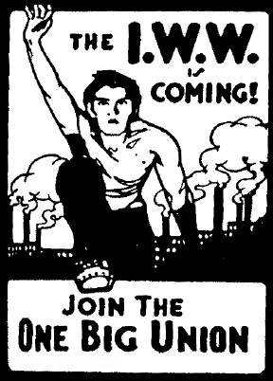A poster for the Wobblies

There was one more big difference between the IWW and other unions. Other unions wanted small changes, like a little more money for their members. The IWW wanted to change everything. They wanted every worker to be in one big union. They wanted the workers to control all the companies and the government. They also wanted to stop all wars. They believed wars made poor people kill each other, and helped rich people get richer. The IWW was the last big union in the US to have these ideas.

Vocabulary
- discriminate - verb – To do bad things to someone because of who they are: their skin color, where they're from, if they are a man or a woman, or if they are gay, for example.
- skilled – adjective – Someone with good skills, usually skills for high-paying jobs.
- industrial- adjective – Like factories. “Industrial work is hard but pays a lot of money.”
- organize – verb – When you teach people about a problem and help them fix it, or when you get people to join a union. “We need to organize the workers at my restaurant.”
- cooperate – verb – To work with someone. “The neighbors cooperated to build a house.”
- members – noun – The people in an organization. “My church group has 20 members.”
- decision – noun – What you choose. “I made a decision to find a new job.”
Vocabulary Practice
1.__ discriminate | a. When you teach people to fix their problems, or help them join a union
2.__ skilled | b. What you choose
3.__ industrial | c. The people in an organization
4.__ organize | d. Someone with good skills, usually skills for high-paying jobs
5.__ cooperate | e. Like factories.
6.__ members | f. To do bad things to someone because of who they are: skin color, where they're from, if they are a man or a woman, if they are gay
7.__ decision | g. To work with someone
8.__ ________ | h. When workers stop working to get what they need

The Wobblies and Other Unions
 | The IWW in 1905 | Other 1905 unions | Most unions today
What kind of workers can join? | 1. | Skilled white workers only | 2.
Cooperate with the boss? Have contracts? | Did not cooperate, no contracts. | 3. | 4.
Do they want to change everything? | 5. | Only wanted to change a little bit. | 6.
Do they believe in war? | 7. | 8. | Some yes, some no.

Questions
1. What do you like about the IWW? What don’t you like?

2. Do you think unions for skilled white men agreed with the IWW? Why?

3. Do you think the US government liked the IWW? Why?

4. What do you think happened to the IWW?
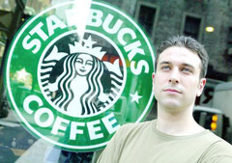

The Wobblies Today
There’s about 1000 Wobblies in the US and 1000 more around the world today. Wobblies still organize workers other unions won’t organize. In the US they’re organizing workers at Starbucks, truck drivers and artists. The IWW also protests for immigrants’ rights and against the war in Iraq.

