World War I
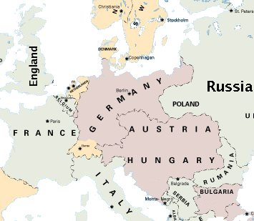 Europe in 1914

In 1914 Europe was richer than ever before. Every European country wanted to be the strongest in the world. There was new technology everywhere: electricity, airplanes, and more. This technology helped them make new weapons. Europeans were excited about the future. Europeans were excited about war.

World War I started in 1914, when the nephew of the king of Austria-Hungary was killed by a Serbian man. No one expected this to start the biggest war in the world. But Austria-Hungary started a war with Serbia. The Germans supported Austria-Hungary, and Russia supported Serbia. Now three of the biggest countries in Europe were fighting a war.

When Russia sent soldiers to Serbia, it scared Germany. Germany was in the middle: Russia was on the east and France was on the west. They were both Germany’s enemies. If they both attacked at the same time, Germany would lose. If Germany wanted to win, they had to quickly attack France and Russia first.
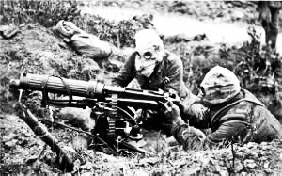 A World War I machine gun

Germany attacked Russia and France. England and the US supported France. Every country thought they were going to win. Every country had new weapons. But it was the first European war in a long time, so no one knew the right way to use them. Thousands of soldiers ran into machine guns (see picture). Almost all of them were killed. Different countries also used poison gas. You had to put on a gas mask (see picture) very quickly or it would kill you. Thousands more soldiers were killed by poison gas. About 9 million soldiers and 6 million others were killed in World War I - over 15 million people altogether.
 A gas mask

The war lasted longer than most people expected. In the end, France, England and the US won. Germany lost, and Austria-Hungary broke into a few different countries. No one was happy at the end of World War I. No one was excited about new technology and weapons. European countries weren’t rich anymore, and everyone knew they were living in a more dangerous time.

Vocabulary
1. technology – noun – Machines, or parts of machines. “There’s new technology in my phone.”
2. weapon – noun – Something you use to hurt or kill someone. “Guns are dangerous weapons.”
3. expect – verb – What you think will happen. “I didn't expect to lose my job.”
4. support – verb – To help someone. “I support my family at home.”
Questions
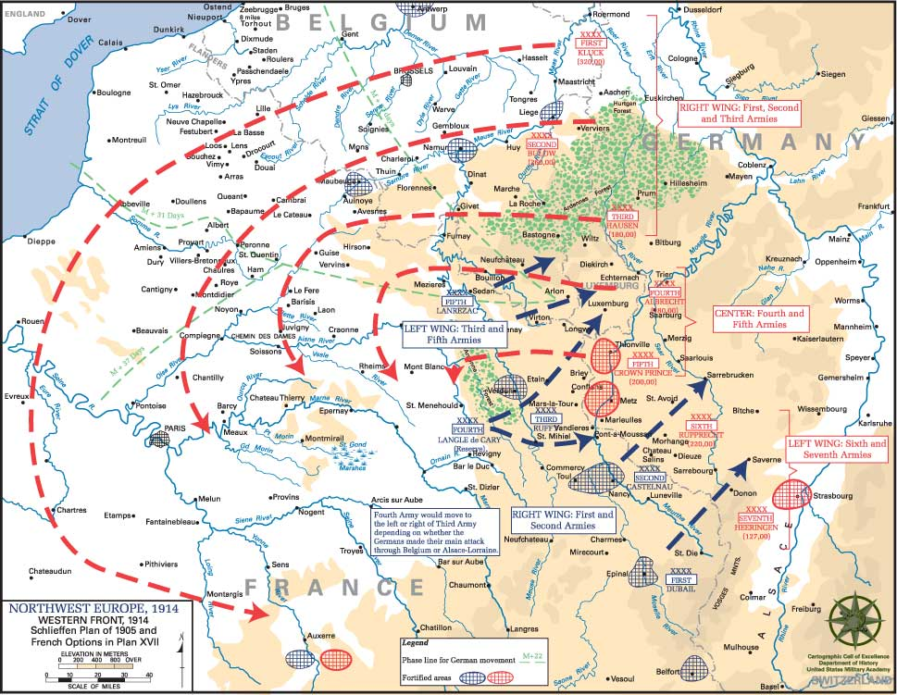A map of the fighting in WWI
1. Why did World War I start? Was it a good reason to start a war?

2. Why was World War I different?

3. How did Europeans feel before the war? How did they feel after?

4. What’s different today? What’s the same?

